**R Computer Lab #2**

This lab was done in collaboration with four other students: Guðrún Carstensdóttir, Helga Margrét Ólafsdóttir, Laufey Ásta Guðmundsdóttir and Sigrún Ósk Jakobsdóttir

**Question 1 - Item Response Functions and Person Estimates**

**(a) Which item was the easiest item and which item was the hardest? (2 points)**est_params <- rasch_model$est  
colnames(est_params) <- c("Discrimination", "Difficulty", "Guessing")  
rownames(est_params) <- paste("Item", 1:18)  
est_params

Item 5 is the easiest - 1.62671110  
Item 10 is the hardest - 0.52959427  
   
**(b) Provide a 95% confidence interval for the easiest item and interpret it. (2 points)**est_se <- rasch_model$se  
colnames(est_se) <- c("Discrimination SE", "Difficulty SE", "Guessing SE")  
rownames(est_se) <- paste("Item", 1:18)  
est_se

Item difficulty +/- 1.96*SEM

-1.62671110 + 1.96 * 0.1320051 = -1.37  
-1.62671110 - 1.96 * 0.1320051 = -1.88

-1.37 lower bound og -1.88 upper bound

95% probability that the item difficulty is between -1.37 and -1.7

**(c) Provide a plot that contains both the easiest and the hardest item. (1 point)**

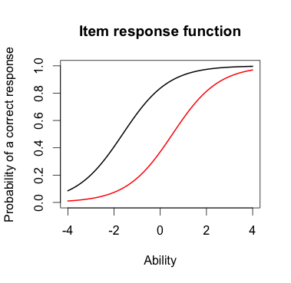  
The black line represents the easier item.

**(d) What would we expect the probability of a correct response would be for someone who had an ability score of 0 for these two items? (2 points)**

For item 5, the black line – around 0.4

For item 10, the red line – around 0.8

**(e)  What was the score of the person who did the best on the test? What was the score of the person who did the worst on the test? (2 points)**est_abl <- as.data.frame(mlebme(Scored, ip = est_params))  
min(est_abl$est) # Prints the minimum score  
max(est_abl$est) # Prints the maximum scores  
which.min(est_abl$est) # Prints out the person minimum score  
which.max(est_abl$est) # Prints out the person with the maximum score

Person number 49 did best on the test with the score 3.999921  
Person number 393 did the worst with the score -3.999947

**(f) Provide a 95% confidence interval for the estimated ability for the student who did the best on the test and interpret it. (2 points)**

The student who did the best on the test is person number 49 with the estimated ability of 3.999921 and SEM of 2.204373.

Ability score +/- 1.96*SEM

3.999921 + 1.96 * 2.204373 = 8.3

3.999921 - 1.96 * 2.204373 = -0.32

95% confidant that the person´s ability lays between 8.3 and -0.32

**Question 2 – Information**For this question, you will choose three items to investigate.

**(a) Please state the three items you selected. (1 point)** plot(iif(est_params[c(7,9,13),]), co = NA)

Items 7, 9 and 13

**(b) Provide a plot that contains these three items’ information functions. (1 point)**

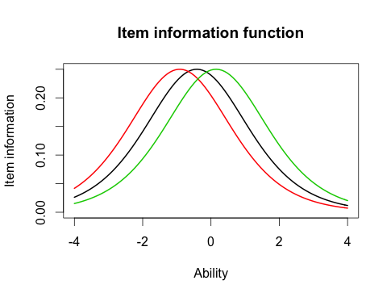

**(c) What is the same about these items’ information functions? What is different? Hint: This can be a very short answer. (2 point)**

The shape of function is the same but the item difficulty (item location) is different.

**(d) Provide a plot of the test information function. (1 point)**

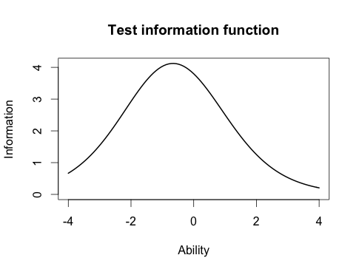

**(e) Where is the majority of the information for this test located? (1 point)** plot(tif(est_params))

Most of the information is located around 0.5, between 0 and 1. It is easier to discriminate between the test scores of students who are located between 0 and 1.

**Question 3 - Comparing the 2-PL**

**(a) Which item had the highest discrimination? Which one had the lowest discrimination? (2 point)**twopl_params <- twopl_model$est  
colnames(twopl_params) <- c("Discrimination", "Difficulty", "Guessing")  
rownames(twopl_params) <- paste("Item", 1:18)  
twopl_params

Item 8 has the highest discrimination = 2.2881772  
Item 12 has the lowest discrimination = 12, 0.3329130

**(b) Are the items that were the easiest and hardest in the Rasch model, also the easiest and hardest  in the 2-PL? (1 point)**

No, they are not the same at the Rash model and the 2-PL.

**(c) What is the correlation between the ability estimates on the Rasch model and the 2-PL? If your interest was solely on estimating person abilities, do you think you would draw the same conclusions from both models? Why? (2 point)**cor(twopl_abl$est,est_abl$est)

The correlation between the ability estimates on the Rasch Model and the 2-PL is 0.9709497. It is almost the perfect correlation. Then it doesn’t matter what model we use to evaluate the ability.

**(d) Provide a plot of the item information function for the three items you selected in Question 2 but this time for the 2-PL model. (1 point)** 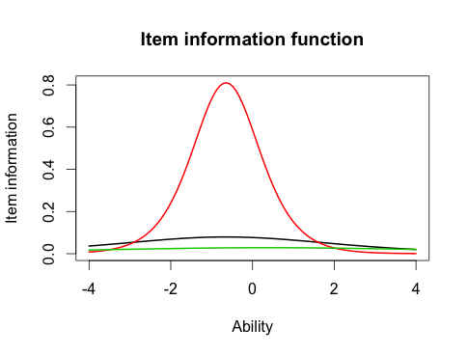

**(e) For the 2-PL model, how do the item information functions for these items differ? How do the 2-PL item information functions from these items differ from their Rasch item information functions? (2 point)**

2-PL model allows for discrimination. Both the black and green lines have a huge range and small information. Therefore it is difficult to discriminate between the test takers. However, the red line has the largest discriminator. It is easier to discriminate between the test takers on that item.